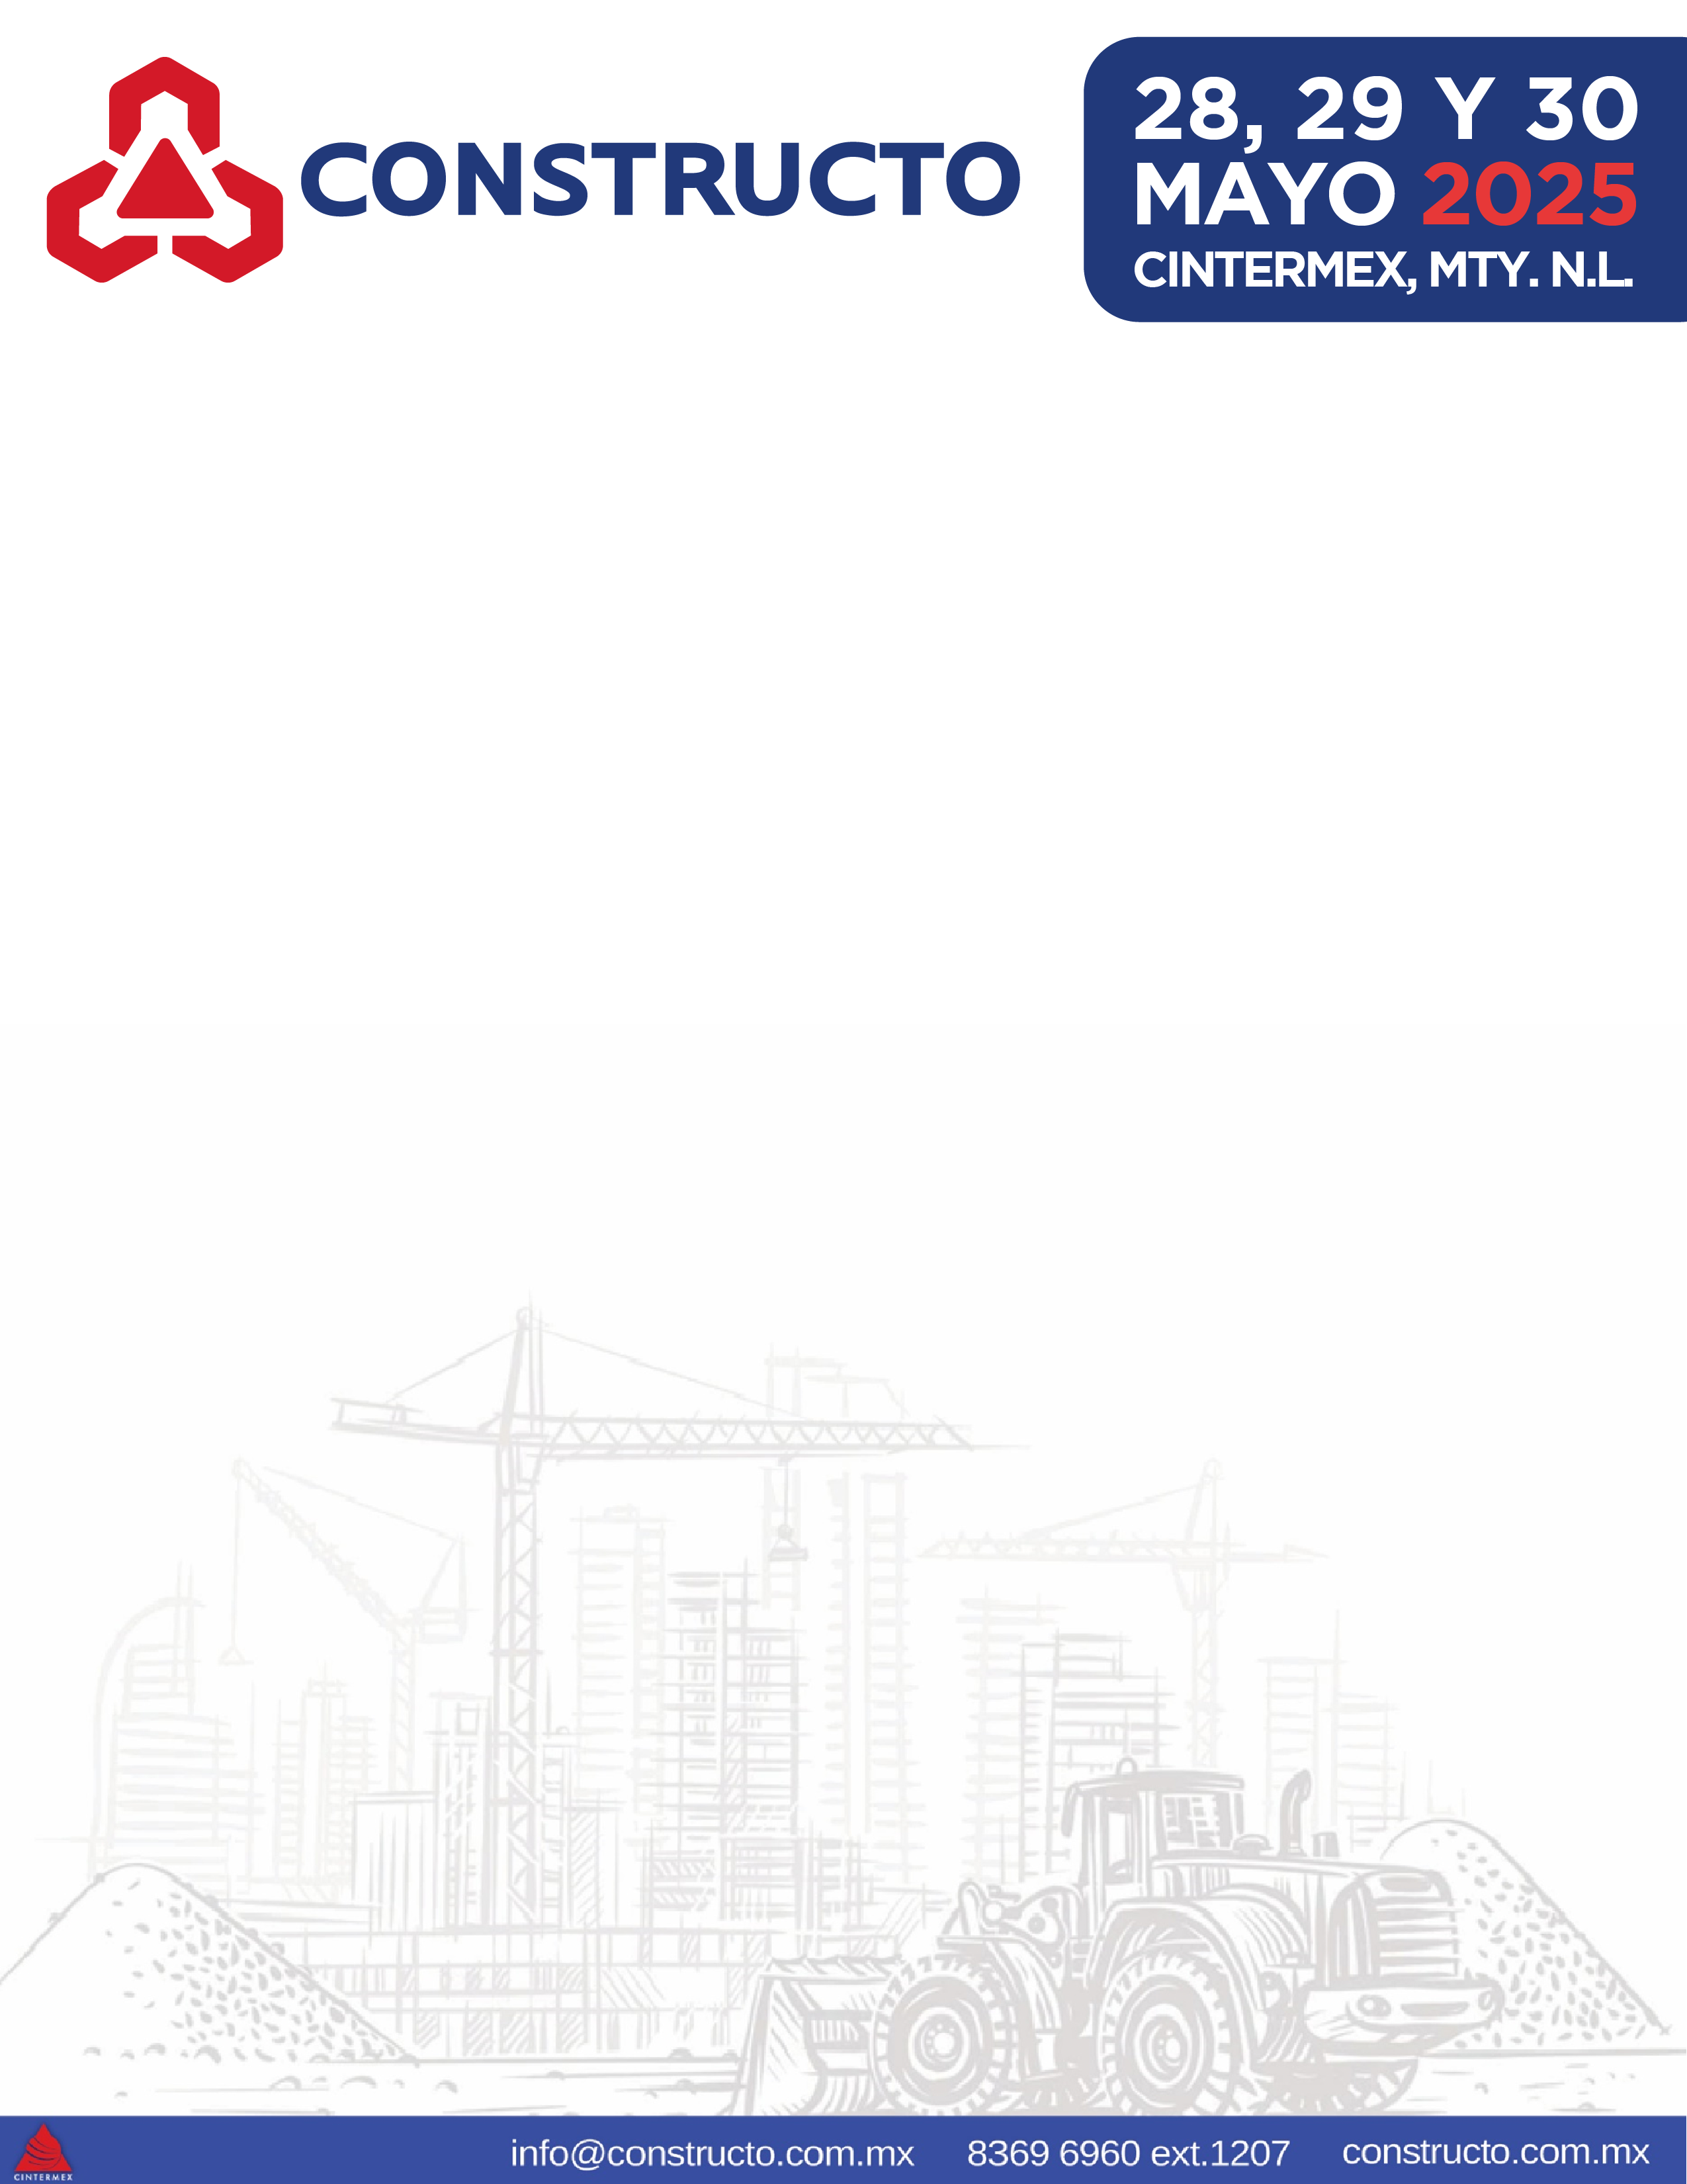
Monterrey, Nuevo León México
DATE*

To whom it may concern.-
CINTERMEX SiDEC is a company that organizes exhibitions of different types of industries, we organize EXPO CONSTRUCTO which will take place from April 24 to 26, 2024 at Centro Internacional de Negocios, CINTERMEX, in the city of Monterrey, N.L. Mexico.

EXPO CONSTRUCTO has developed as the most important event in the construction industry in Mexico and brings together the leading companies in the sector every year. For this reason, we extend this letter of invitation to the company _______________________________________ ., which will be participating as an exhibitor.
Below you could find the details of the person who will be traveling and representing the company _________________________________________ :
Name:
Date of birth:
Passport number:

We appreciate your support towards this company and its representative, I remain at your disposal for any questions or clarifications.
S I N C E R E L Y . –
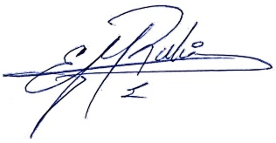
Edgar Medina
-Exhibition Development Manager.
General Coordinator of EXPO CONSTRUCTO.
CINTERMEX.

